**“Online Quiz System”**

**PROJECT REPORT**

**Submitted for the course: CSE3002 Internet and Web Programming**

**By**

**SHUBHAM GUPTA 16BCE0232**



**October, 2018**

**Table of content**

1. **Abstract**
2. **Introduction**
   * 1. **Problem Statement**
     2. **Technical Specification**
3. **Existing system problems**
4. **Proposed system design**
5. **Results (Database design, Table schema and screen shots)**
6. **Conclusion**
7. **References**

**1.Abstract**

This document specially mentions the details of the project how it was developed, the primary requirement, as well as various features and functionalities of the project and the procedures followed in achieving these objectives.

ONLINE QUIZ forms the lifeline of the Educational Institutes to the functioning of the Examination. It is very essential for an Institute to handle the Examinations and their results. It is very useful for an Institute to test its students continuously for their mutual development. This system is helpful for conducting (M.C) Multiple Choice Examinations which can be conducted regularly as well as for surprise tests and provides immediate results saving the precious time of faculties to check the papers and prepare mark sheets. The IT initiatives have encouraged various Organizations to develop systems to facilitate their day to day operations. The ONLINE QUIZ will include various Courses (IT, Commerce, Science, etc and subjects for conducting examinations. This system helps in conducting examinations quickly and can thus help in saving time and the operations will be carried out efficiently. With the effective use, any Institute can apply the “ONLINE QUIZ” for conducting quick examinations and getting better results in less time.

**2.Introduction**

**2.1Problem statement**

Today many online quizzes are set up to actually test knowledge or identify a person's attributes. Some companies use online quizzes as an efficient way of testing a potential hire's knowledge without that candidate needing to travel. Online quizzes are a popular form of entertainment for web surfers. Online quizzes are generally free to play and for entertainment purposes only though some online quiz websites offer prizes. Websites feature online quizzes on many subjects.

**2.2Technical Specification**

Online Electronic Application Store Database will do following processes

1. Any member can register .
2. Only registered member view the quiz.
3. There are three roles available: Visitor, User and Instructor.
4. Visitor can view online quiz.
5. User can view and participate in quiz.
6. An Instructor has some extra privilege including all privilege of visitor and user. Instructor can add quiz, edit information and add/remove the info.
7. Instructor can add user, edit user information and can remove user.
8. Users can give feedback also.
9. Notice is also available for users.

#### Software Resource Requirements

* Mysql
* JDBC Connector for mysql
* Tomcat Server
* JSP
* Javascript
* Mysql Workbench
* CSS
* HTML
* JAVA servlet
* Netbeans

**MODULES USED**

* HOME
* INSTRUCTOR
* USER
* NOTICE
* EXAM
* RESULT
* FEEDBACK
* SIGN IN
* CONTACT US
* EXAM REPORT

**3. Existing system problems**

Online examination on a computer system in our immediate environment. This Online examination system is designed to assist university administration examination in attaining a standardized sample, and as such the psychological implication of such a design is very important. The design of the system is quite simple and easily understood. Its flexibility makes it amenable for future changes and amendment to either incorporate other aspects of intelligence or to be designed for any other school age or class. The question of the online examination system are programmed and visually displayed on the system's screen in an interactive form. The student answers the question on the computer system, immediately the question is marked and notified. The result of this online examination and are also displayed at the end of the examination which goes a long way to lessen the fears of students that they were marked down in the examination. Since the Online examination is examined by the computer, time cost of manual examination is saved. Based on the virtues of internet amendment which have been made to the examination system concept by constructing a website with online examination, online question setting and answer and online management by the administrator.

Apart from this, the security of online quiz systems is always a serious problem. These systems are usually prone to cyber-attacks. Our project therefore uses JSP which is relatively safe compared to the other conventional alternatives.

**4. Proposed System Design Module description (UML Diagram/pseudocode)**

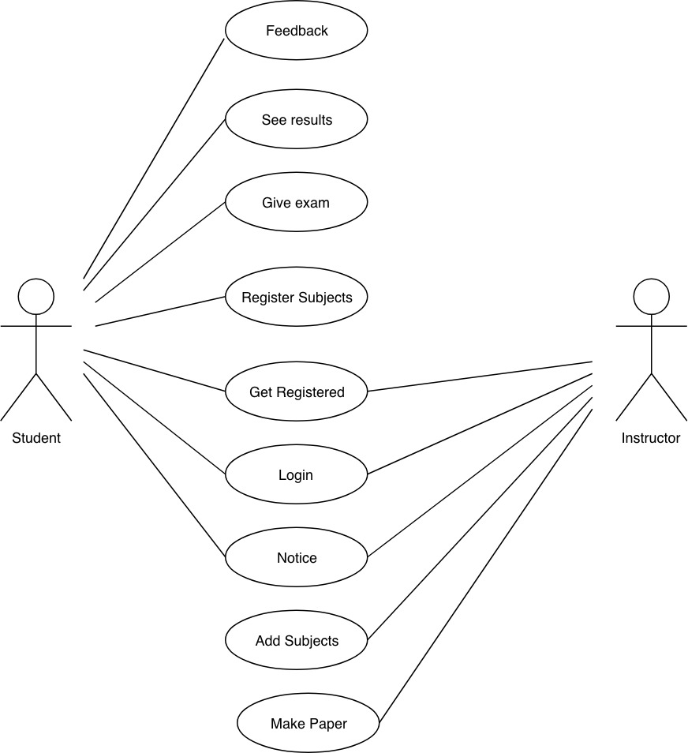

**USE CASE DIAGRAM**

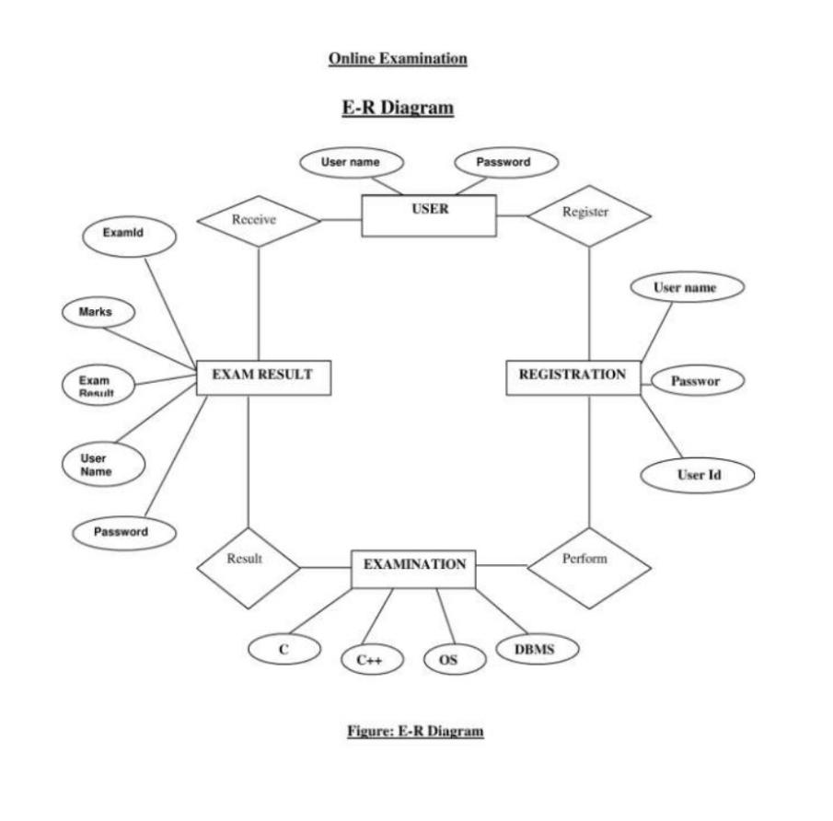

**ER DIAGRAM**

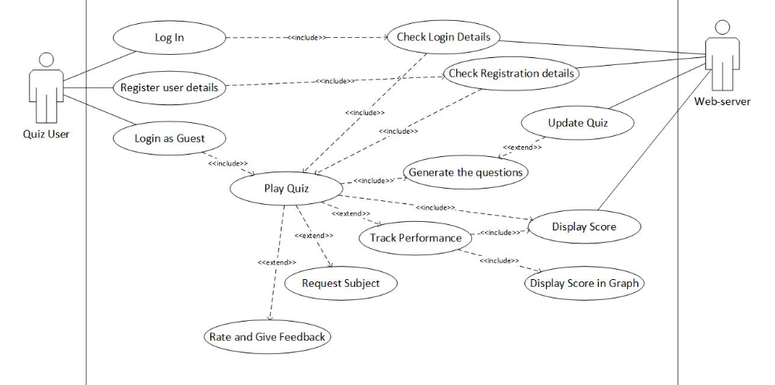

**5. Results (Database design, Table schema and screen shots)**

**INSTRUCTOR TABLE**

mysql> desc Instructor;

+----------+--------------+------+-----+---------+-------+

| Field | Type | Null | Key | Default | Extra |

+----------+--------------+------+-----+---------+-------+

| name | varchar(50) | NO | | NULL | |

| uname | varchar(50) | NO | PRI | NULL | |

| password | varchar(50) | NO | | NULL | |

| sem | varchar(10) | NO | | NULL | |

| address | varchar(100) | NO | | NULL | |

| email | varchar(50) | NO | UNI | NULL | |

| mobileno | varchar(20) | NO | UNI | NULL | |

+----------+--------------+------+-----+---------+-------+

7 rows in set (0.00 sec)

**FEEDBACK TABLE**

mysql> desc feedback;

+---------+-------------+------+-----+---------+-------+

| Field | Type | Null | Key | Default | Extra |

+---------+-------------+------+-----+---------+-------+

| name | varchar(50) | NO | | NULL | |

| rollno | varchar(50) | NO | | NULL | |

| sname | varchar(50) | NO | | NULL | |

| scode | varchar(40) | NO | | NULL | |

| comment | varchar(50) | NO | | NULL | |

+---------+-------------+------+-----+---------+-------+

5 rows in set (0.00 sec)

**NOTICE TABLE**

mysql> desc notice;

+--------+--------------+------+-----+---------+-------+

| Field | Type | Null | Key | Default | Extra |

+--------+--------------+------+-----+---------+-------+

| notice | varchar(300) | NO | | NULL | |

+--------+--------------+------+-----+---------+-------+

1 row in set (0.01 sec)

**PAPER TABLE**

mysql> desc paper;

+-------+--------------+------+-----+---------+-------+

| Field | Type | Null | Key | Default | Extra |

+-------+--------------+------+-----+---------+-------+

| qno | varchar(10) | NO | | NULL | |

| qname | varchar(300) | NO | | NULL | |

| opt1 | varchar(100) | NO | | NULL | |

| opt2 | varchar(100) | NO | | NULL | |

| opt3 | varchar(100) | NO | | NULL | |

| opt4 | varchar(100) | NO | | NULL | |

| ans | varchar(500) | NO | | NULL | |

+-------+--------------+------+-----+---------+-------+

7 rows in set (0.00 sec)

**RESULT TABLE**

mysql> desc result;

+--------+-------------+------+-----+---------+-------+

| Field | Type | Null | Key | Default | Extra |

+--------+-------------+------+-----+---------+-------+

| rollno | varchar(30) | NO | | NULL | |

| sname | varchar(50) | YES | | NULL | |

| scode | varchar(50) | YES | | NULL | |

| no | varchar(10) | YES | | NULL | |

+--------+-------------+------+-----+---------+-------+

4 rows in set (0.00 sec)

**SUBJECT CODE TABLE**

mysql> desc scode;

+-------+-------------+------+-----+---------+-------+

| Field | Type | Null | Key | Default | Extra |

+-------+-------------+------+-----+---------+-------+

| scode | varchar(20) | YES | | NULL | |

+-------+-------------+------+-----+---------+-------+

1 row in set (0.00 sec)

**SUBJECTS TABLE**

mysql> desc subjects;

+-------+-------------+------+-----+---------+-------+

| Field | Type | Null | Key | Default | Extra |

+-------+-------------+------+-----+---------+-------+

| Instructor | varchar(50) | YES | | NULL | |

| sname | varchar(50) | YES | | NULL | |

| scode | varchar(50) | YES | | NULL | |

+-------+-------------+------+-----+---------+-------+

3 rows in set (0.00 sec)

**USERS TABLE**

mysql> desc user;

+----------+--------------+------+-----+---------+-------+

| Field | Type | Null | Key | Default | Extra |

+----------+--------------+------+-----+---------+-------+

| name | varchar(50) | NO | | NULL | |

| rollno | varchar(50) | NO | PRI | NULL | |

| password | varchar(50) | NO | | NULL | |

| sem | varchar(20) | NO | | NULL | |

| address | varchar(100) | NO | | NULL | |

| email | varchar(70) | NO | UNI | NULL | |

| mobileno | varchar(20) | NO | UNI | NULL | |

+----------+--------------+------+-----+---------+-------+

7 rows in set (0.00 sec)

**USERSUBJECTS TABLE**

mysql> desc usersubjects;

+--------+-------------+------+-----+---------+-------+

| Field | Type | Null | Key | Default | Extra |

+--------+-------------+------+-----+---------+-------+

| rollno | varchar(50) | NO | | NULL | |

| sname | varchar(50) | YES | | NULL | |

| scode | varchar(50) | YES | | NULL | |

+--------+-------------+------+-----+---------+-------+

3 rows in set (0.01 sec)

**FRONTEND SCREENSHOTS AND MODULE DESCRIPTION**

**1.HOME**

* Home is the basic module which tells us the purpose and importance of the online quizzes.
* It is the first page of the website and works as the main module of the project.
* A basic UI can be seen completely from the home page.
* It should be attractive and user appealing UI, to make other more interested

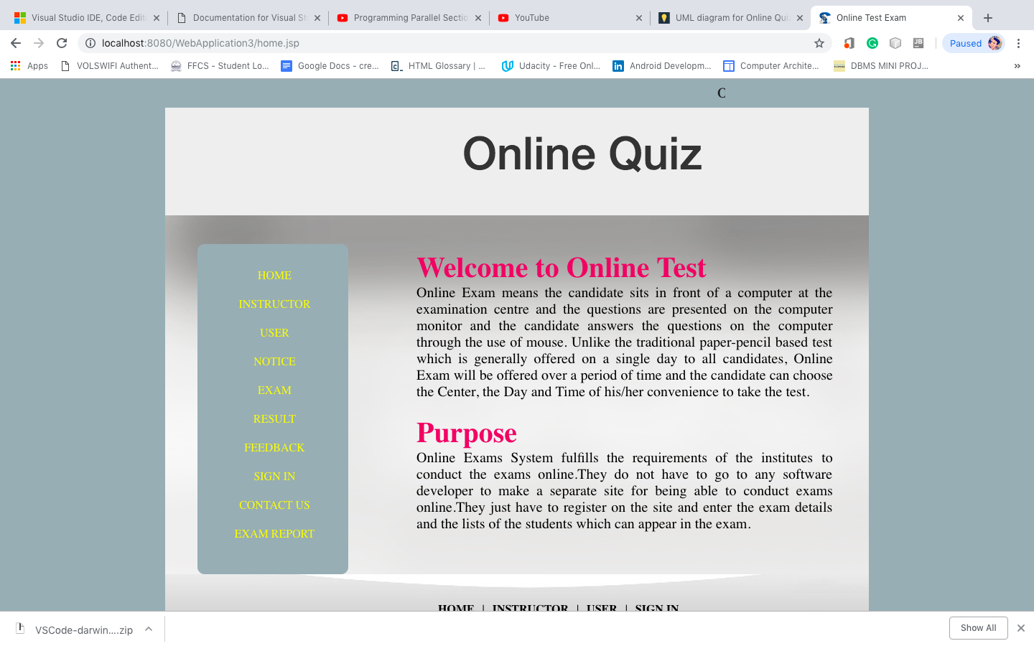

**2.Instructor**

The Instructor consists of five modules:

* Instructor Registration
* Instructor Login
* Make Paper
* Add Subjects
* Notice

The Instructor has special privilege’s to adding and deleting the subjects. Also, the Instructor can make the paper.

The Instructor can also send notice to the users. Allow or disallow users to use the data. Give permission to users.

An individual who is the supreme commander of the website.

Instructor helps in helping user to register and then login as well. Then Instructor helps to create papers and quiz for the subject which that user have choosen.

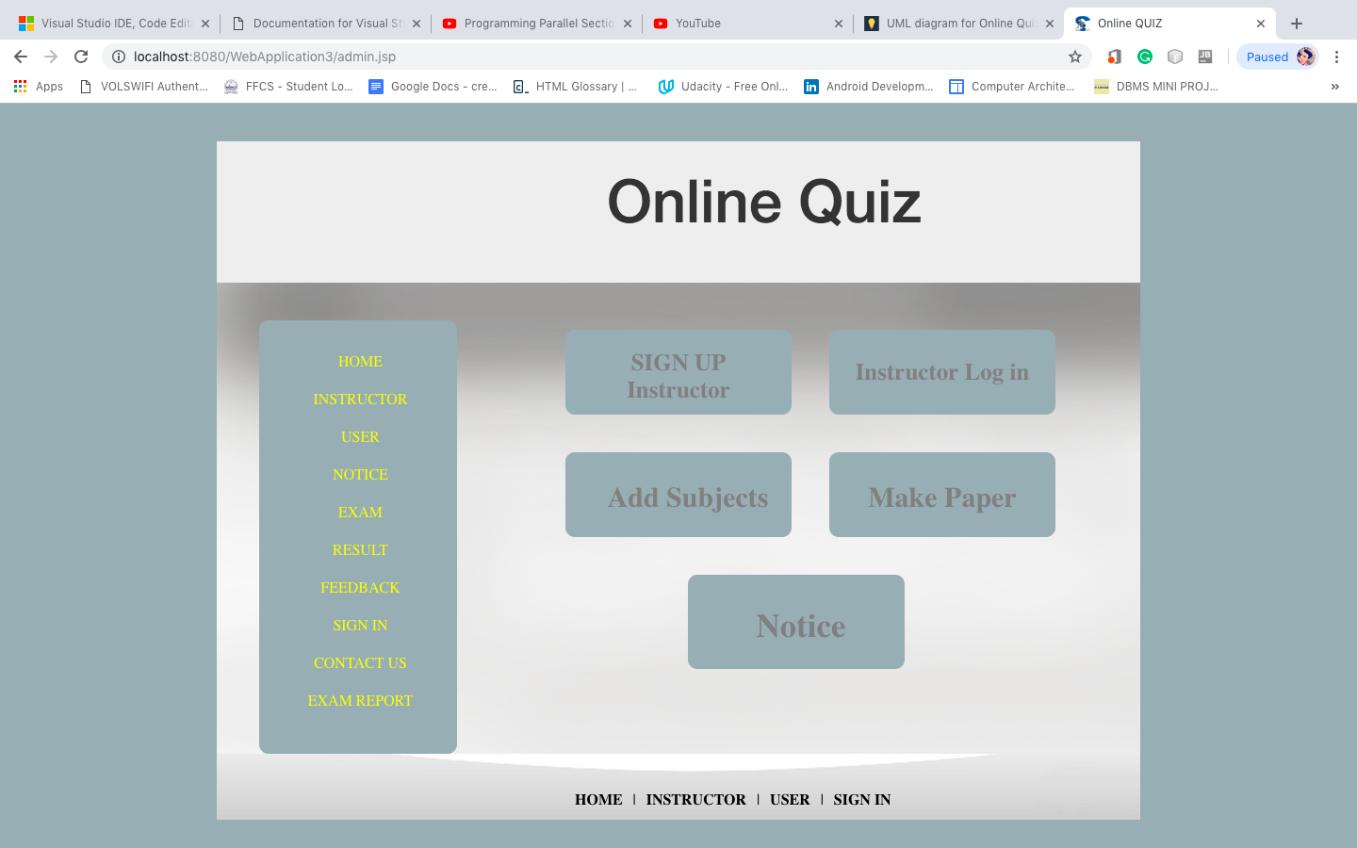

**3.USER**

The user module consists of three modules:

* User Registration
* User Login
* Subject Registration

The user can register using their name, address, registration number, email-id and mobile number. After logging the user can register for a particular subject.

Firstly, user have to register into the website. Then he/she should go for login and getting forward to register for subjects and there respective quizzes.

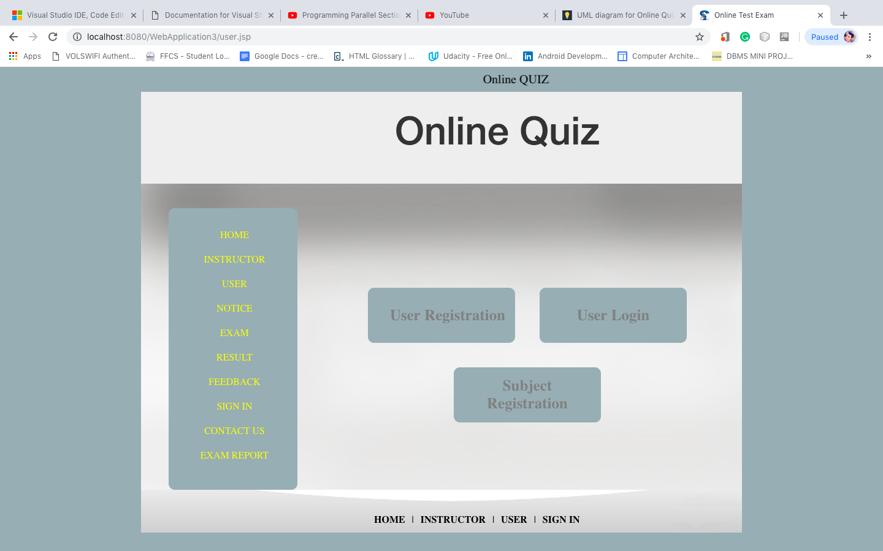

**4.NOTICE**

This module is used for giving information about the important things to the user.

It provides the important information to the user. Helps in translating, conveying the message to the user in a well manner.

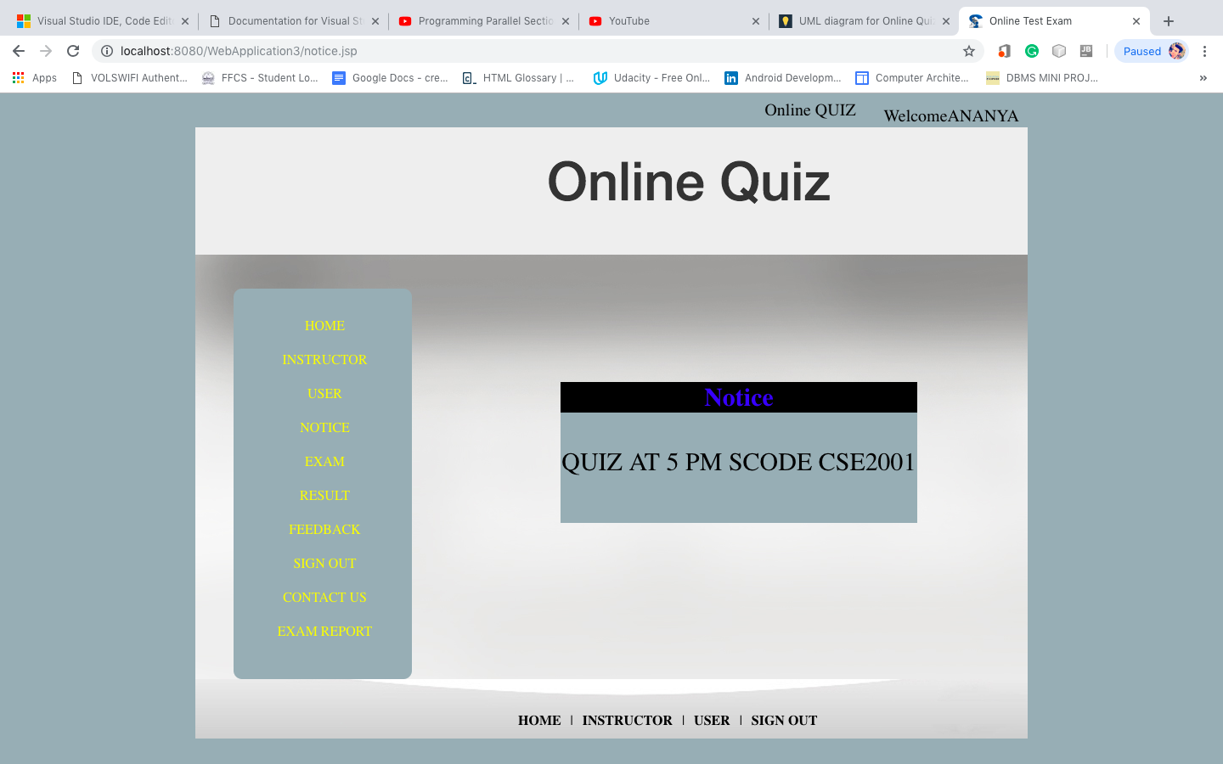

**5.EXAM**

In this module the user can choose the subject using the subject name with subject code and subject name for giving the online exam. This can only be accessed after logging in through the user login. The user can view the questions entered by the instructor along with the multiple options. The user then chooses the option that they feel is correct.

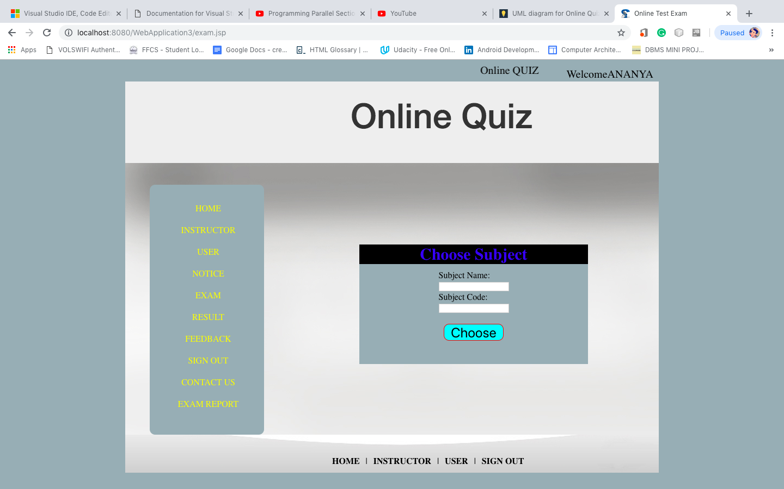

**6. RESULT**  
This module enables the user to see the result of the examination. After choosing answers in the examination, the user’s quiz will be evaluated in the backend. In order to view the result of the quiz, the user has to choose ‘Result’ from the menu after which the score of the quiz will be displayed to the user along with the subject name. The options chosen by the user are compared with the correct options and thus it is determined if the user’s answers is correct or not. These correct answers are entered by the faculty while he sets the paper for the examination. The result of the quiz is therefore automatically displayed after the user completes the quiz. This will be displayed through the user login and not on the faculty’s end. This involves no waiting period as the correct answers are already present in the backend. This is also very time saving as the faculty need not evaluate every single quiz entry individually 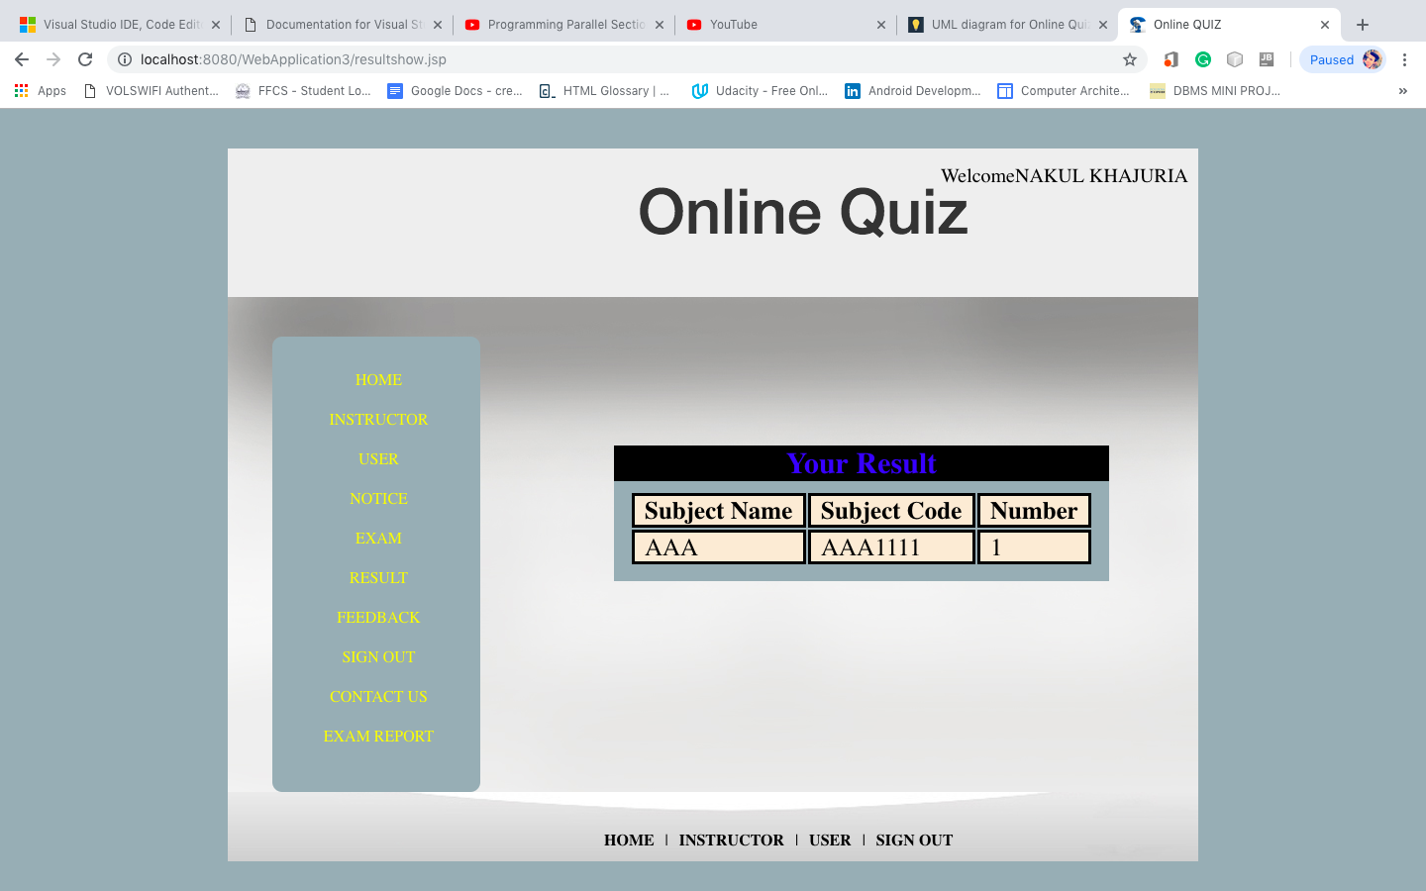.

**7.FEEDBACK**

Once a user has taken a quiz, he can give his feedback about the quiz. This can be regarding any technical difficulties that the user has come across or if the user believes that there is a discrepancy in the questions in the quiz. This too, can be accessed only through a user login as it is the students who take the quiz.

This acts as a medium of communication between the faculty and the student. Feedback need not just be complaints but it can also include things that the user appreciates. Highlighting the positive features can help the faculty maintain the same quality of the quiz when they make another quiz. Feedback that is entered by the user is made visible to the faculty when they login through the admin login by entering their username and password. They then have to choose the subject and view feedback. Each user’s feedback for that subject is then displayed to the faculty along with their usernames.

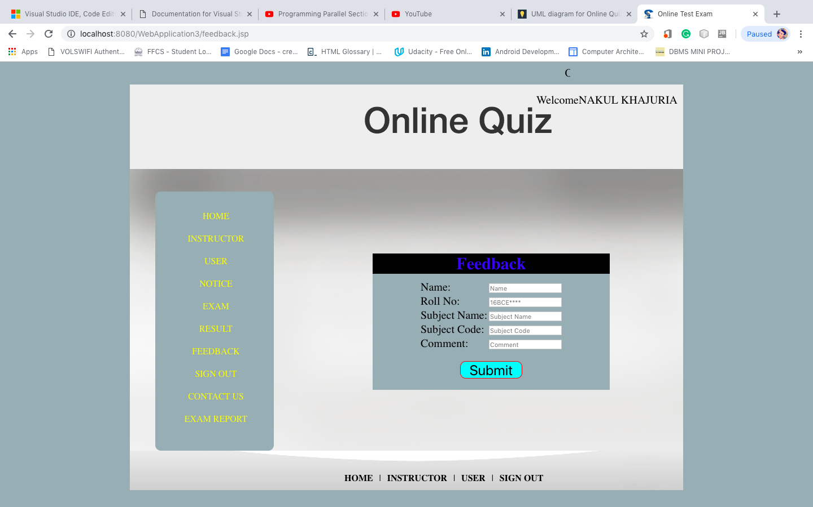

**8.SIGN IN**

This provides an interface for the user and the admin to login. The sign in page is where the user and admin can login in through their respectively. In order to sign in, the user or admin must have already registered and thus have a username and a password that they can use to sign in. The UI of this page displays a login option if the user is currently not signed it. Clicking the login option leads to a choice between a user and an admin login. After choosing either of the two, one has to enter their username and password. These details are compared with the database of registered users and the the systems signs them in only if there is a match. If there is no match, an error message is displayed.   
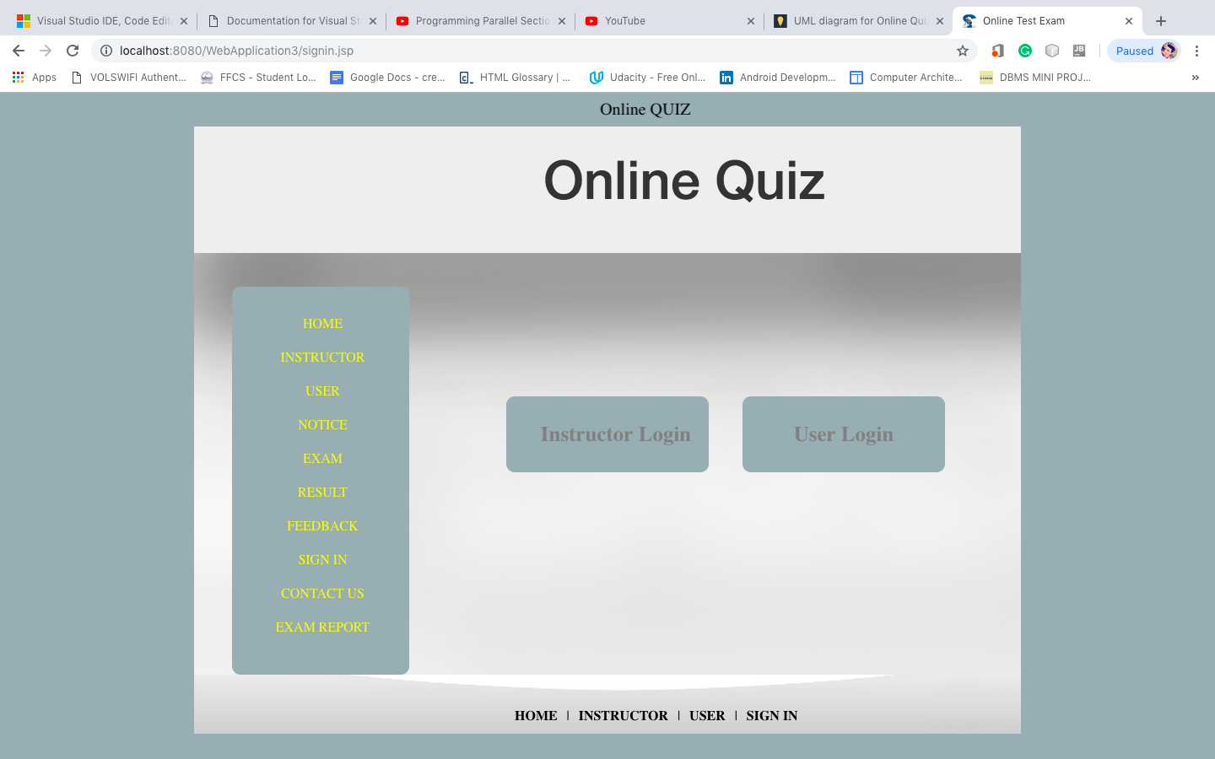

**9.CONTACT US**

The UI includes a simple webpage that displays the contact details of the online quiz providers. Both the users and the admins can view this page as it is useful to both parties. In a situation where there is a technical difficulty with the online quiz system, the user or the admin can contact the service providers with this problem. This can involve any problem from registering a user, logging in or having troubles while taking the exam. Due to this reason, the contact details can be viewed without registering or logging in. The developers can also be contacted by the students or faculty in order to request additional features that would make the online quiz process simpler.

Unlike the feedback page, where there is an option of sending a message, the contact us page does not act as a medium but merely displays basic details like phone number, email id etc. This therefore gives the students and the faculty access to the developers that created and are now maintaining the online quiz system.

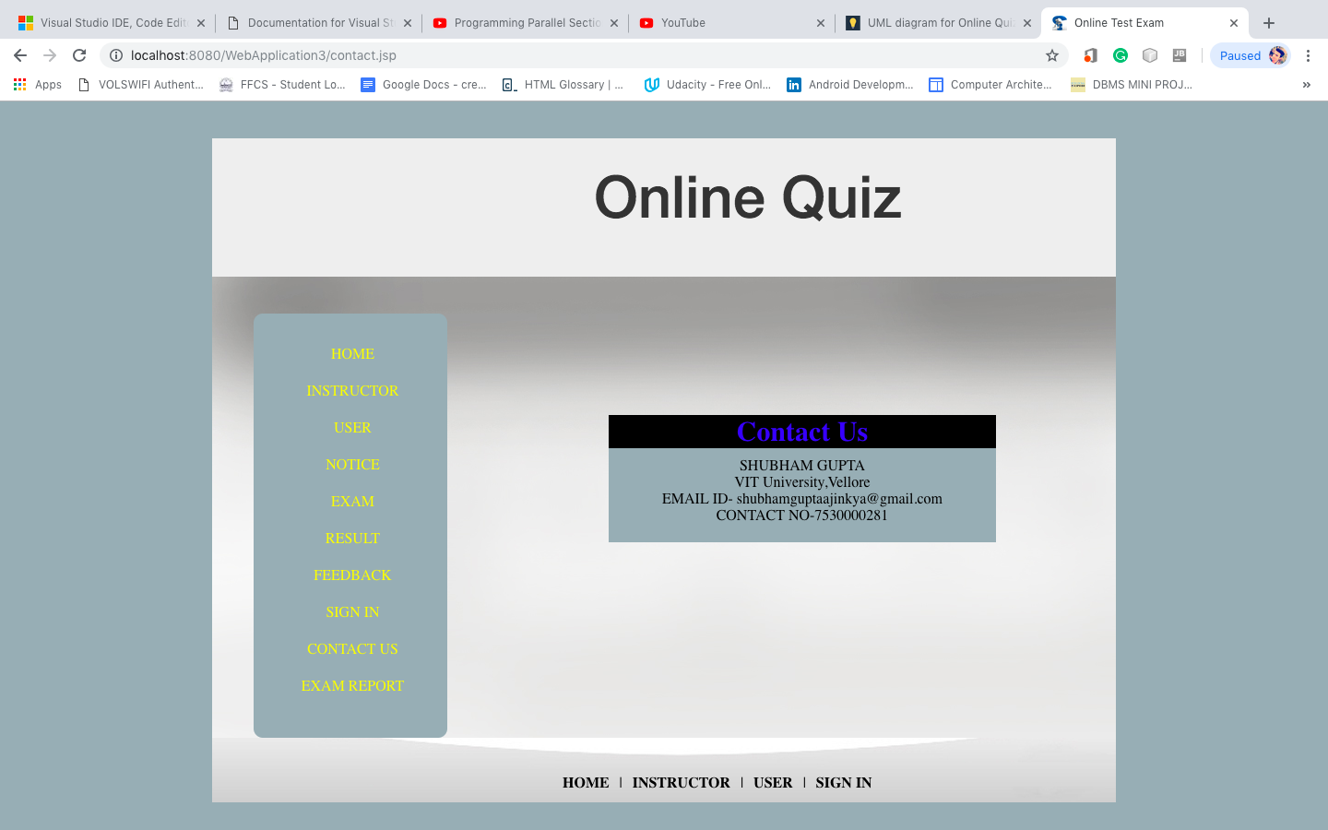

**10. REPORT**

This page gives a detailed report of the user’s performance in the examination. After logging in and completing one or more quizzes, the user has to click on the report in the menu displayed. After which the user can choose a subject for which they want to view their quiz report. Once the user chooses the subject , all the questions of the quiz are displayed along with the answer that the user has entered. It is displayed whether the answer entered by the user is correct or incorrect. Irrespective of whether the answer entered by the user is correct or not, below each question, the correct answer to the question is displayed. These correct answers are entered by the faculty while he makes the quiz. Apart from this, the marks that the user has scored in the quiz will also be displayed. This report can only be viewed from the user’s end. 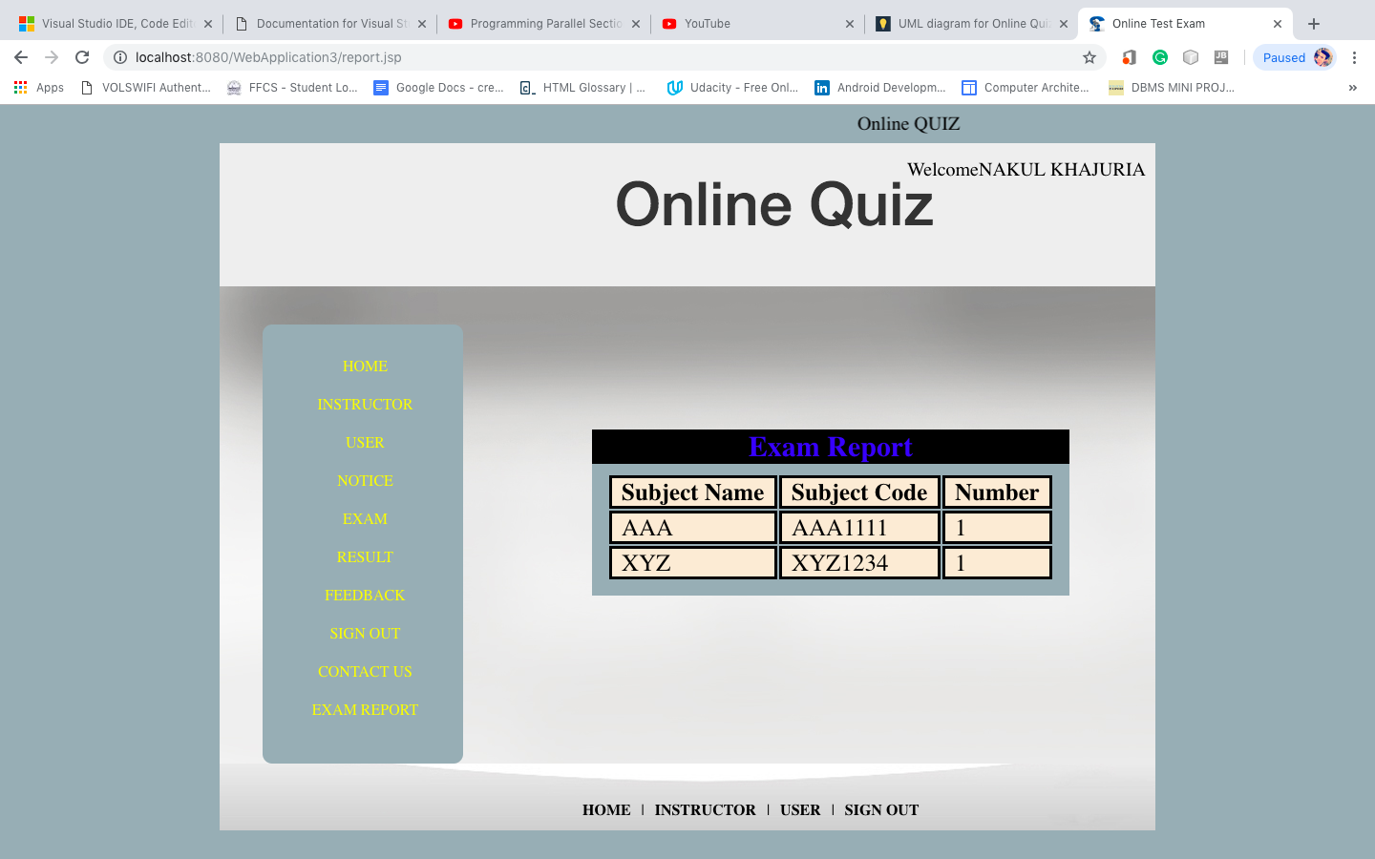

**6. Conclusion**

**According to the recent trends in academics, new trend of exams and quiz is coming into light. There will be a admin who provided assistant to the user and teachers. User and teachers can register their self’s and create a quiz using this application. Using this application time will be saved and wide number of questions will be provided to students to increase their subject knowledge and learn more about the subject. Moreover, this online quiz system is the new way of taking class tests or lab tests. Makes the teacher less stressed and more concentrated on choosing good questions for students.**

**7.References**

* <https://www.thecrazyprogrammer.com/2016/04/online-quiz-system-project-jsp-java.html>
* <https://www.javatpoint.com/online-quiz-project>
* <http://calorisplanitia.com/online-quiz-system.aspx>
* <https://www.researchgate.net/publication/265355956_DESIGN_AND_DEVELOPMENT_OF_ONLINE_QUIZ_USING_THE_OPEN_SOURCE_SYSTEM>
* <https://www.scribd.com/document/262461532/Objective-of-Online-Quiz-System>